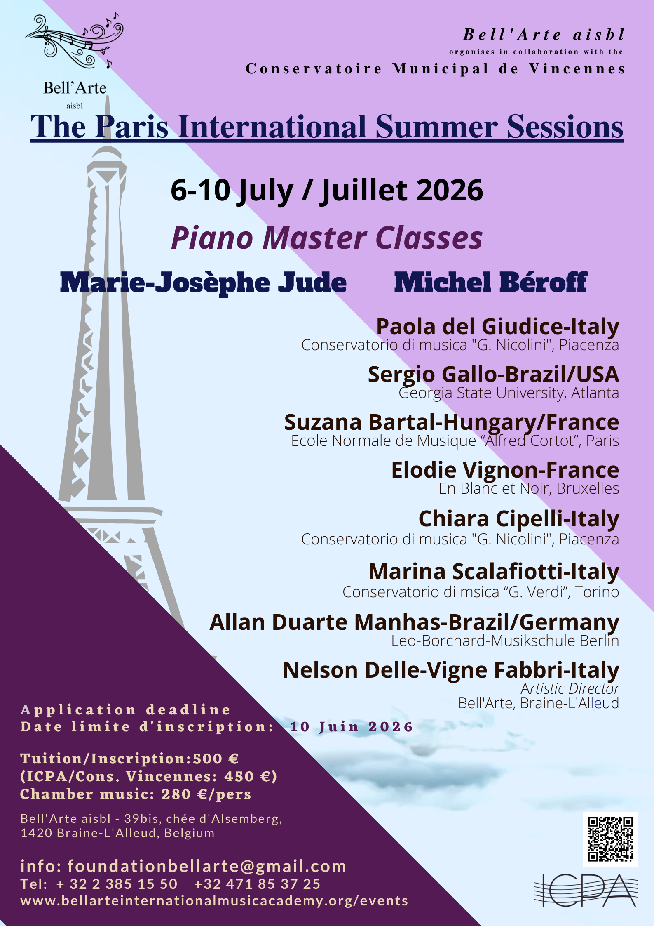

APPLICATION FORM
THE PARIS INTERNATIONAL SUMMER SESSIONS 2026

Date limite 10/6/2026 Deadline

Photo

Audition video by June 15th at the latest.
à renvoyer à/to send to:
Hilde DELLE-VIGNE
e-mail: foundationbellarte@gmail.com

or by regular post
39bis, chaussée d’Alsemberg
1420 Braine-L’Alleud BELGIQUE
!!! NO REGISTRED MAIL ACCEPTED!!

Tel: +32 2 385.15.50 - Mobile: +32 471 85.37.25 (SMS)
PLEASE TYPE OR WRITE IN BLOCK LETTERS

O picture inserted on the form - O audition video

Nom/Name: …...........................................

Prénom/ Given name: ......................……..

Genre/gender: ...............…...........

O Elève actif/active participant O Auditeur/observer

O piano

O 2 pianos-4 hands* O chamber music*
*nom des partenaires-formulaire séparé / name of partners – separate application form

Lieu et Date de naissance / Place and Date of Birth: ………………………………………………..………………………………….…………………
Genre/Gendre : …………………………………….. Nationalité/nationality: …….....................................………………………
Adresse/Address : ...……………………………………….………….…………………………………………………………………………………………………….

.…………………………………………………………………………………………………………………………………………………………………………………………

Tél/Phone:…………………………..……………. e-mail:………..…………………………………....................................................................

Diplômes/Diplomas - Niveau/Level/Degrees:
.…………………………………………………………………………………………………………………………………………………………………………………………
.…………………………………………………………………………………………………………………………………………………………………………………………
Professeurs précédents / former teachers: …………………………………………………………………………………………………………………….

.…………………………………………………………………………………………………………………………………………………………………………………………
Professeur actuel / Current teacher : …………………………..............................................................

Œuvres proposées - proposed works (complete information)

1) .…………………………………………………………………………………………………………………………………………………………………………………………
2) .…………………………………………………………………………………………………………………………………………………………………………………………
3) .…………………………………………………………………………………………………………………………………………………………………………………………
4) .…………………………………………………………………………………………………………………………………………………………………………………………
Optional: suggested work for a Master Class (the piece can not exceed 12 minutes)
1)……………………………………………………………………………………………………………………………………..…..………………………………………………

O Elève Conservatoire Municipal de Vincennes/ICPA
(copie de la carte d'étudiant à joindre - copy of student card must accompany this application)

Accommodation:
During the course my address will be: …………………………………………………………………………….……………………………………………………

.…………………………………………………………………………………………………………………………………………………………………………………………

Téléphone / Phone…………………………...............................................................

Payment Details:
Application fee: 80 Euros

inscription/tuition fee: ……...………. Euros

International bank transfer: + 10,00 Euros

total amount ........….…………...... Euros

Bank datas:
Account number: BE81 0019 2719 8424 SWIFT: GEBABEBB
Bank: Fortis , rue Montagne du Parc, 3, 1000 Bruxelles-Belgique

NO CHEQUES ACCEPTED!!-PAS DE CHEQUES!
SEULE LA RECEPTION COMPLETE DU DROIT D'INSCRIPTION CONFIRMERA CELLE-CI.
ONLY THE RECEPTION OF THE COMPLETE AMOUNT WILL CONFIRM YOUR APPLICATION.
En cas de non-réception du montant exact, la différence sera réclamée au début du stage. –Pas de remboursement après la date limite d’inscription.
In a case where the exact amount was not received, the difference will be claimed at the beginning of the course.
La preuve du paiement doit accompagner le présent bulletin d'inscription.
The proof of the payment must accompany the present application

Refunding policy: www.bellarteinternationalmusicacademy.org/paris-summer-sessions

Signature (by parent or legal guardian if under 18 years old)

X …………………………………………………………………………………………

THE PARIS INTERNATIONAL SUMMER SESSIONS 2026

www.bellarteinternationalmusicacademy.org/paris-summer-sessions

Application Fee: 80 € (Not refundable) In case of chamber music, this fee is due per person.
+
Tuition
- Piano solo:420 Euros (ICPA-Cons. Vincennes: 370 €) - listener: 100 €)
- Additional discipline: + 120 €
- Chamber music- 2 pers: 200 €/person

Application fee & Tuition must be paid by June 10th. Proofs must be joined to the application form.
Only those who paid the complete amount will be scheduled for the course.
The course accepts also experienced amateurs. Participants under 18 must be accompanied by an adult.
Refund Policy
www.bellarteinternationalmusicacademy.org/paris-summer-sessions
Place of the course
Conservatoire municipal de Vincennes: « Coeur de Ville » - 98 Rue de Fontenay, 94300 Vincennes, France
Welcome Meeting on Monday, July 6th, at 10 a.m.
The planning of the lessons and the practical aspects will be communicated on this occasion.
At 10:30 a.m.: Beginning of the lessons.
Chamber music is possible in the following combinations: 2 pianos - 4 hands piano - strings/piano (pianist comes with its partner.s)
Special Events
Master classes
~ High level Piano Master classes given by Special Guests Marie-Josèphe JUDE and Michel BEROFF
Concerts
~ Several concerts will take place during the course.
~ Friday July 10: end of the lessons at 6 pm followed by the final concert
For the master classes, the organization will make a selection among the students.

The organizing committee is allowed at any time to modify organization elements and/or to decide an eventual cancellation of the course, if the circumstances require it.
_________________________________________________________________

Admission requirements
- For active participants: curriculum vitae, recommendation letter from a teacher.
- 2 ID pictures - sticked on the application form or jpg file
- Audio or video recording (15') for the selection of the master classes must be sent by June 15th at the latest.
- For the participants, minor of age, the application form has to be signed by a legal responsible.
- For the master classes: Students need to bring copy of the score for the master.
APPLICATION FORM: www.bellarteinternationalmusicacademy.org/paris-summer-sessions
- Make sure to meet all the requirements for your stay in France, if necessary.
_________________________________________________________________

Transport
- From the airport: RER B (till “Châtelet-Les Halles”) and RER A (till “Vincennes”) will take you to Vincennes.
- RER A station "Vincennes" is at a 7 min walk from the conservatory
- Bus stop in front of the Conservatory: lines 118 & 124
- Metro Line 1, Stop "Château de Vincennes" is at a 10 minutes walk from the Conservatory
Accommodation
The Conservatory is located in Vincennes, in the building “Coeur de ville”, across the Mairie. We recommend you to find housing in that area.
♪♫♪♫♪♫

